**PYTHON BASICS**

**PYTHON INTRODUCTION:**

* Python is an object-oriented way or functional way, high level programming language & scripting language.
* It was developed by **Guido van Rossum**, and released in 1991.
* It can contains large no.of libraries/modules/packages/frameworks.
* Python runs on an interpreter system, meaning that code can be executed as soon as it is written. This means that prototyping can be very quick.
* Python is an open-source programming language which means that anyone can create and contribute to its development.

**Uses :**

* Python programming is used for software development, web development, data analysis, task automation, data visualization, designing, system scripting, machine learning and much more.

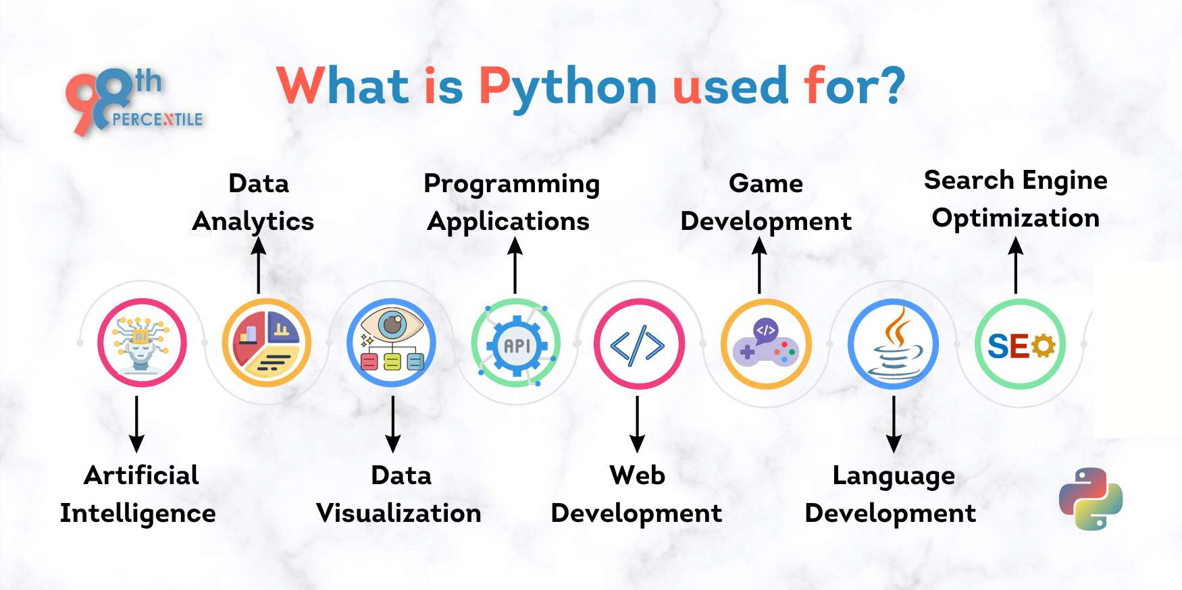

* Python works on different platforms (Windows, Mac, Linux, Raspberry Pi, etc).
* Python has a simple syntax similar to other English language.
* It can connect to database systems. It can also read and modify file.

**PYTHON INSTALLATION**

1. Install Python, firstly download the Python distribution from official website of python (www.python.org/ download).
2. Before starting working with Python, a specific path is to set to set path follow the steps: Right click To on My Computer--> Properties-->Advanced System setting-->Environment Variable-->New
3. In Variable name write path and in Variable value copy path up to C:// Python (i.e., path where Python is installed). Click Ok->Ok.

**PYTHON IDE’S**

* IDLE (Integrated Development and Learning Environment)
* Pycharm
* Jupyter
* Visual Studio Code
* Sublime Text 3
* Atom
* Spyder
* PyDev
* Thonny
* Wing
* Pyscripter
* Visual Studio
* Vim
* GNU/Emacs
* Dreamweaver:
* Eric
* Rodeo

**Python syntax :**

Python syntax can be executed by writing directly in the Command Line

>>> print("Hello, World!")

Hello, World!

**Python Indentation :**

Indentation refers to the spaces at the beginning of a code line.

if 5 > 2:

  print("Five is greater than two!")

**PYTHON COMMENTS**

1.Single line comment : this comment starts with a #, and Python will ignore them(it means that code will not be considered).

#single line comment

2. Multiple line comment : this comment starts and ends with triple quote

"""

This is a comment

written in

more than just one line

"""

**PYTHON VARIABLES**

Variablesareusedtostorethevalue or address of a value, to create a variable first we have to give a value to it.

**Rules** :

1. Don’t start with symbols/digits
2. Starting letter should be alphabets and underscore( _ ).
3. Case sensitive(upper and lower cases).

**Syntax :**

**Variable name = Value**

a=10

print(a)

Output = 10

**DATA TYPES**

There are different types of data types in Python. Some built-in Python data types are:

* **Numeric data types**: int, float, complex
* **String data types**: str
* **Sequence types**: list, tuple, range
* **Binary types**: bytes, bytearray, memoryview
* **Mapping data type**: dict
* **Boolean type**: bool
* **Set data types**: set, frozenset

**NUMERI DATA TYPES** :

Numeric data type is used to hold the numeric values.

1. int - holds signed integers of non-limited length.

n=3

print(int(n))

>>output = 3

1. float- holds floating precision numbers and it’s accurate up to 15 decimal places.

a=2

print(float(a))

>>output = 2

1. complex- holds complex number

v=4+3j

print(type(v))

output = <class”complex”>

**TYPE CONVERSION :**

The process of converting the value of one data type (integer, string, float, etc.) to another data type is called type conversion. Python has two types of type conversion

1. **Implicit Type Conversion:**

* In implicit type conversion, Python automatically converts one data type to another data type. This process doesn't need any user involvement.
* example where Python promotes the conversion of the lower data type (integer) to the higher data type (float) to avoid data loss.

1. **Explicit Type Conversion:**

* In Explicit Type Conversion, users convert the data type of an object to required data type. We use the predefined functions like int(), float(), str(), etc to perform explicit type conversion.
* This type of conversion is also called typecasting because the user casts (changes) the data type of the objects.

**STRING DATA TYPES**:

String is a collection of characters and it used when we have festival data.

Types of declaring strings

1. Single quotes (ex: ‘NAME’)
2. Double quotes(ex: “NAME ”)
3. Trible quotes(ex: ‘’’NAME’’)

a='pythonlife'

b="pythonlife"

print(type(a),type(b)

Output: <class 'str'> <class 'str'>

**STRING METHODS :**

|  |  |
| --- | --- |
| [count()](https://www.w3schools.com/Python/ref_string_count.asp) | Returns the number of times a specified value occurs in a string |
| [endswith()](https://www.w3schools.com/Python/ref_string_endswith.asp) | Returns true if the string ends with the specified value |
| [find()](https://www.w3schools.com/Python/ref_string_find.asp) | Searches the string for a specified value and returns the position of where it was found |
|  |  |
| [format()](https://www.w3schools.com/Python/ref_string_format.asp) | Formats specified values in a string |
| [index()](https://www.w3schools.com/Python/ref_string_index.asp) | Searches the string for a specified value and returns the position of where it was found |
| [upper()](https://www.w3schools.com/Python/ref_string_isupper.asp) | Converts a string into upper case |
| [lower()](https://www.w3schools.com/Python/ref_string_lower.asp) | Converts a string into lower case |
| [lstrip()](https://www.w3schools.com/Python/ref_string_lstrip.asp) | Returns a left trim version of the string |
| [replace()](https://www.w3schools.com/Python/ref_string_replace.asp) | Returns a string where a specified value is replaced with a specified value |
| [rstrip()](https://www.w3schools.com/Python/ref_string_rstrip.asp) | Returns a right trim version of the string |
| [split()](https://www.w3schools.com/Python/ref_string_split.asp) | Splits the string at the specified separator, and returns a list |
| [splitlines()](https://www.w3schools.com/Python/ref_string_splitlines.asp) | Splits the string at line breaks and returns a list |
| [startswith()](https://www.w3schools.com/Python/ref_string_startswith.asp) | Returns true if the string starts with the specified value |
| [strip()](https://www.w3schools.com/Python/ref_string_strip.asp) | Returns a trimmed version of the string |
| ends with() | Returns true if the string start with the specified value |
| [title()](https://www.w3schools.com/Python/ref_string_title.asp) | Converts the first character of each word to upper case |
| [translate()](https://www.w3schools.com/Python/ref_string_translate.asp) | Returns a translated string |
| [upper()](https://www.w3schools.com/Python/ref_string_upper.asp) | Converts a string into upper case |

**SEQUENCE TYPES**

1. **List** :

* Lists are used to store multiple items in a single variable, and store different types of elements.
* Lists are created by using square brackets.
* Lists are allows the duplicates and also indexing.
* Lists are mutable type data type(modification is available).

a=[1,2,3,4,5,]

print(a)

Output:[1, 2, 3, 4, 5]

**List methods:**

|  |  |
| --- | --- |
| [append()](https://www.w3schools.com/python/ref_list_append.asp) | Adds an element at the end of the list |
| [clear()](https://www.w3schools.com/python/ref_list_clear.asp) | Removes all the elements from the list |
| [copy()](https://www.w3schools.com/python/ref_list_copy.asp) | Returns a copy of the list |
| [count()](https://www.w3schools.com/python/ref_list_count.asp) | Returns the number of elements with the specified value |
| [extend()](https://www.w3schools.com/python/ref_list_extend.asp) | Add the elements of a list (or any inerrable), to the end of the current list |
| [index()](https://www.w3schools.com/python/ref_list_index.asp) | Returns the index of the first element with the specified value |
| [insert()](https://www.w3schools.com/python/ref_list_insert.asp) | Adds an element at the specified position |
| [pop()](https://www.w3schools.com/python/ref_list_pop.asp) | Removes the element at the specified position |
| [remove()](https://www.w3schools.com/python/ref_list_remove.asp) | Removes the first item with the specified value |
| [reverse()](https://www.w3schools.com/python/ref_list_reverse.asp) | Reverses the order of the list |
| [sort()](https://www.w3schools.com/python/ref_list_sort.asp) | Sorts the list |

1. **Tuple :**

* It will use when data is in constant.
* It will allows different types of elements and also allows duplicates,and indexing & slicing.
* In tuple we can’t use any methods ,we can use only builtin (ex:max….,min,max,sum,et…).
* It is a immutable type data type (it means data can’t be modified).

TUPLE A